Github repo link
https://github.com/LimpehBlurBlur/INF1103-Labs.git

Docker mount and run
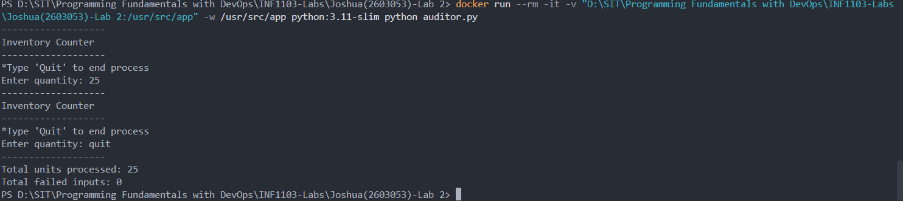

Docker image
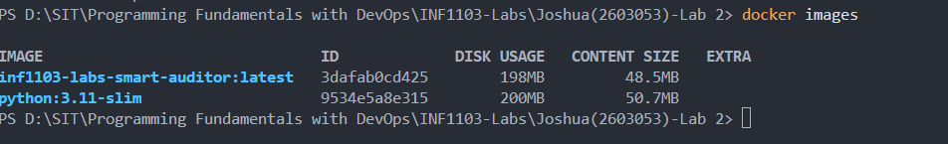

Docker image working with accepting inputs and producing results
